Learning Journal Unit 3

An Assignment submitted in partial fulfillment of the requirements for the degree of
Bachelor of Science
in
Computer Science

CS 2205: Web Programming 1
Term 2 - 2025
University of The People

December 5, 2024

Part A: HTML <form> method Attribute
From the W3Schools HTML Tutorial, HTML form controls enable user interaction. The HTML <form> method Attribute specifies how to send form-data (the form-data is sent to the page specified in the action attribute). The form-data can be sent as URL variables (with method="get") or as HTTP post transaction (with method="post") (W3Schools, 2024). Here are four chosen form controls:
- Text Input (<input type="text">): Allows users to input text data, such as a name.
- Password Input (<input type="password">): Similar to text input but hides the characters typed, used for sensitive data like passwords.
- Radio Buttons (<input type="radio">): Allows users to select one option from multiple choices.
- Submit Button (<input type="submit">): Sends form data to the server.
Two Forms
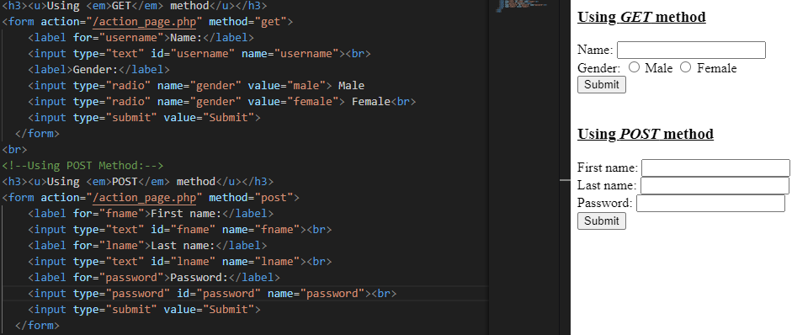
Differences in Outputs
According to W3Schools (2024), GET method appends data as name/value pairs to the URL (URL?name=value), while POST method embeds form data in the HTTP request body. The POST method limits visibility to nearly 3000 characters, while POST method has an unlimited number of characters, but it is invisible in the URL. Finally, the GET method is suitable for bookmarking and non-sensitive data, while POST method is preferred for secure and large data submissions.
Part B: Best suited form control elements
- Choose your marital status from the available options: Single, Married, Widow, prefer not to say.
I would go for radio buttons because it allows users to select only one option from a list of mutually exclusive options. For that reason, the user can only choose one marital status from the options provided. Therefore, radio buttons are ideal for this kind of choice.
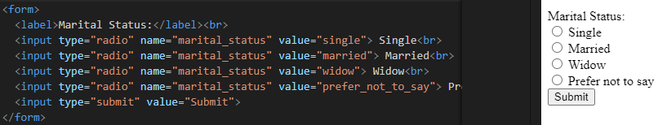
- Indicate whether you have any medical history of diabetes (yes or no).
The best form control for this task is radio buttons as well. Users are required to choose either "yes" or "no," making radio buttons the most appropriate choice for binary responses. The user can select only one option ("yes" or "no"), and radio buttons are designed for binary choices.
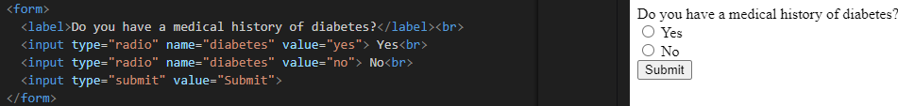
- Write feedback for a food delivery service.
I would choose text area (<textarea>) for this task because it allows users to input multi-line feedback, making it ideal for comments or reviews. Moreover, the user may need to provide detailed feedback, and a text area gives them more space for writing compared to a text input.
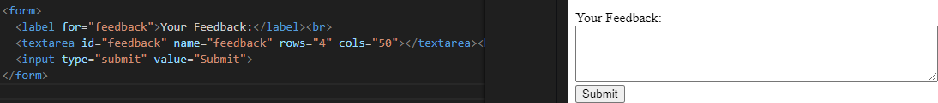
- Select your favourite sport from a list of eight sports.
The best form control for this task is select drop-down list (<select>), which presents the user with a list of eight sports to choose from, making a drop-down list ideal for this scenario. It is to mention that a select drop-down is efficient when there are multiple options, and it saves space compared to displaying a list of radio buttons.
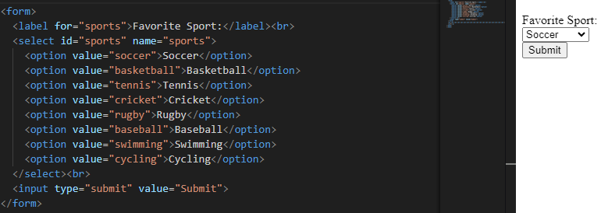

Reference
W3Schools. (2024). HTML <form> method Attribute. W3Schools Online Web Tutorials. https://www.w3schools.com/tags/att_form_method.asp

